JOHN HANCOCK - PROJECT COEUS FRONT END ASSEMBLY 1
Deployment Guide

Revision History
Author | Revision Number | Date
veshu | 1.0 | 5/15/2016

Deployment Instructions 3
1. Organization of Submission 3
2. Application Setup 3
3. REST API Server Setup 3
4. Configuration 3
5. Deployment 3
6. Verifications 4
6.1. Login Page 4
6.2. Menu and Home Page 6
6.3. Add Assessment Page 6
7. Resource Contact List 12

Deployment Instructions

Organization of Submission

Directory / File Name | Description
\Docs\ | The deployment guide.
\Src\Server | The REST server source code.
\Src\App | The frontend application source code.
\TestFiles | The database scripts to load test data.

Application Setup
REST API Server Preconditions:
- Windows Server 2008+ with Active Directory is installed. (Required)
- Microsoft SQL Server 2012 is installed. (Required)
- Microsoft IIS 8.5 (Optional, can also run in IIS Express)
- Visual Studio 2015 is installed. (Required)

Frontend App Preconditions:
- Microsoft IIS (Required)

REST API Server Setup
Please check previous deploy guide
Src\Server\docs\Deployment Guide.doc

Configuration
Please check file Src\App\js\config.js.
Usually you only need to change REST_SERVICE_BASE_URL.

property name | Description | example value
REST_SERVICE_BASE_URL | the base URL of rest API | http://localhost
DATE_FORMAT | The date format to use on the application | ' MMM dd, yyyy' See here for more options
KPISLA_ASSESSMENT_CATEGORY_ID | The category id for KPI/SLA Assessment | see the config.js
NOTE:
- Other properties in config file are moreover constants, used in views. So, you don’t need to configure them unless modifying code.

Deployment
Deploy the Src\App on IIS as
  - Configure the application.(see 4.Configuration)
  - Open IIS manager and Add new site.
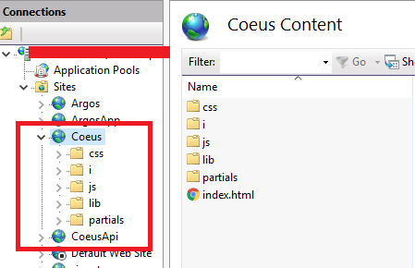

Note: The site must be at root level. Not under other sites.

  - Browser the application. You must see the login page.
Note: If you don’t see the login page most probable issue is your folder doesn’t has the permission for IIS user. Set the permission on Src\App for the IIS User.

Verifications
- You need to have at least 2 user accounts who can login to the application:
- See Src\Server\docs\Deployment Guide.doc to create the user on AD.
Username | Role | Purpose
Any | Owner | To check with owner user
Any | Any Approver(see backend deployment guide) | To check with approver user

- I have hosted on port 8098, so my URL is http://localhost:8098/
- Insert test data on database by running TestFiles\TestData.sql on your database
- Permissions are as:
- All users can login the application using username and password.
- The owner user can only create assessment.
- The approver can only login for now.

- Now browse the application and verify

Login Page
- Go to http://localhost:8098/
- Login screen should show as
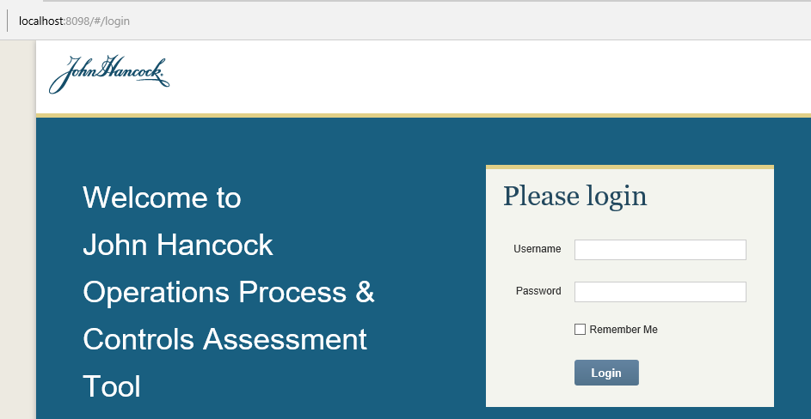
- Click login button without filling value, error should be shown as
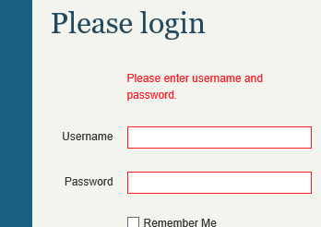
- Enter wrong credentials and verify message

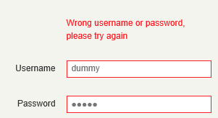

- Login with any approver with correct credentails, you should be redirected to home page

- Try to go to http://localhost:8098/#/addAssessment and see it should not be rendered for other user except user with Owner role
- Verify logout
- Verify “Remember me”
  - Login by selecting the remember me checkbox
  - After successful login close the browser
  - Go to base url (mine is localhost:8098 ) and hit enter
  - You will redirected to home page based on role

- Similarly you can verify login with other credentials if needed.
- To verify token expire, login to the application and then delete all records from [dbo].[Tokens] table
DELETE [Tokens]
And try to perform some action or refresh the page.

Menu and Home Page
- Verify menu based on role
Note: UI is only supported for Owner and Approver, this doesn’t handle for admin user.
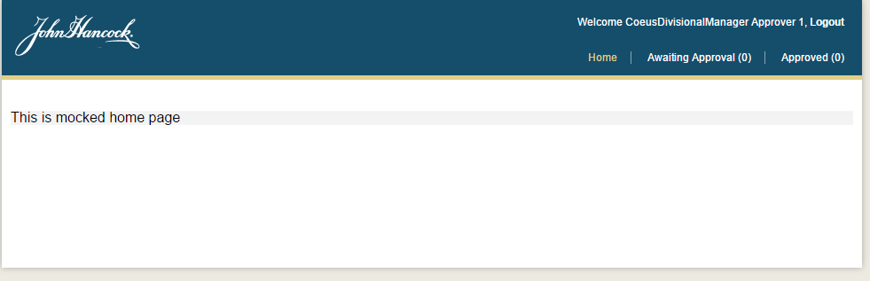
[Fig 1. Home page and menu for approver user]
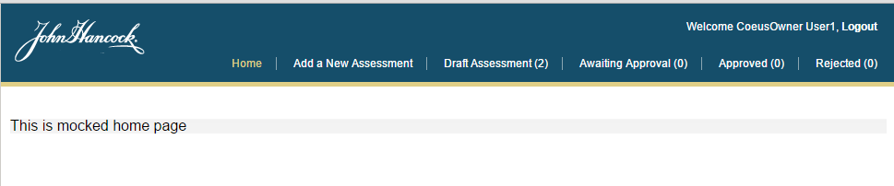
[Fig 2. Home page and menu for owner user]

Note: I have not prepared the test data for assessments so count’s of assessments in menu can be zero because, it will be easy for verification of creation. You can update the assessments from database to check the count.

Add Assessment Page
- Login to the application with owner user
- Click on “Add a New Assessment” link on menu or go to http://localhost:8098/#/addAssessment, following page will shown
Note: The dropdown will take some time to load, depending on your API server performance and network connectivity and there are more lookup items which are called sequentially by browser.
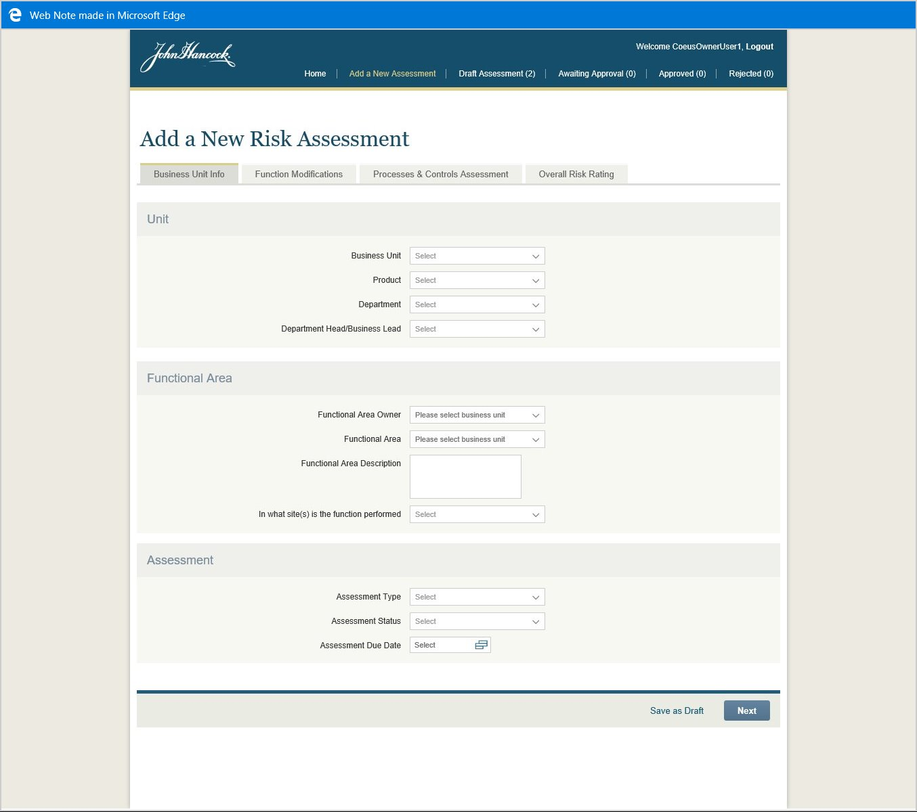

- Select the site’s in which function is performed and select the percentage in each site.
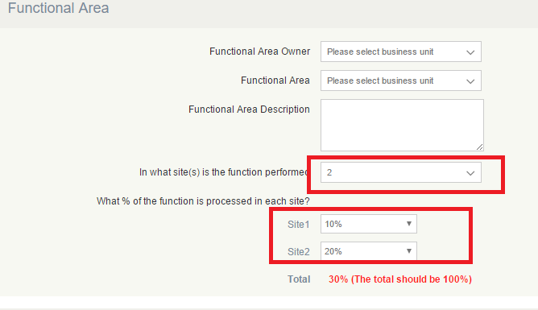
- Now you can save assessment in draft status.
- Click on “Save as draft” button to save in the draft status. You can fill other values as required, which are all optional to save in draft.
Note: To be able to select the control type in “Process and Control Assessment” tab, you need to select the business unit and functional area from “ Business Unit Infor” tab.
  - Select business unit, then only functional area dropdown will be updated
  - Select functional area dropdown, then only control types will be populated
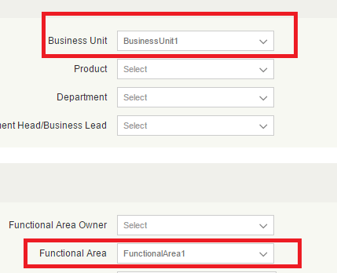

Then you will see items in control type dropdown
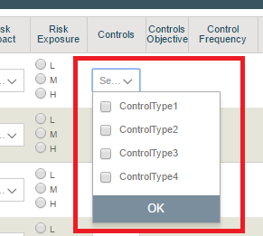

- Remember to select “BusinessUnit1” and “FunctionalArea1” otherwise controls might be empty. You can change the control types from database if needed to check with other functional area.

- “Function Modification” tab.
  - In this tab, for each control you have to select all three values “Change Type”, “Change Time” and “Change description” otherwise while saving it will be discarded.
- Fill the required values and go to “Overall Risk Rating” tab
  - Verify export, it will download the excel file and prompt to save depending on your browser setting
  - Verify print button, it will use browser’s print functionality
  - Verify Save button to save as draft
  - Verify Submit button to send the assessment for approve.
- Once saved in either draft or with submit after successful operation, you will be redirected to home page.
- To verify data, please follow backend deployment guide and verify using Postman. To get the id of newly created assessment use following command in SQL server.
select top 1 * from [dbo].[Assessment] order by 1 desc;
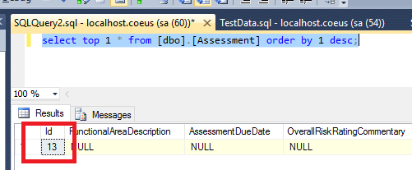
- Use above id with postman, you should the detail of assessment
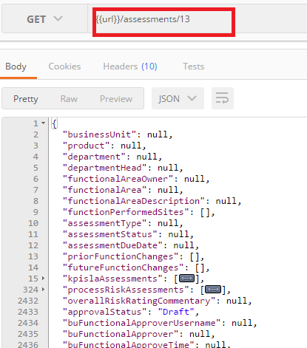
- Charts:
- For successful on every call, you have configure in such way that the expression won’t contain null value, e.g. submitter name will always be sent from application, so I have used following expressions for testing.
<!-- Expressions for RiskScoreCalculator, note that expressions are trivial for testing purposes -->
<register type="IDictionaryString" mapTo="DictionaryString" name="Expressions">
<constructor />
<method name="Add">
<param name="key" value="ResidualOverallRiskScore" />
<param name="value" value="assessment.SubmitterUsername.Length * 2.5" />
</method>
<method name="Add">
<param name="key" value="ResidualCategoryRiskScore" />
<param name="value" value="assessment.SubmitterUsername.Length + 2.4" />
</method>
<method name="Add">
<param name="key" value="LikelihoodOfOccurrenceOverallRiskScore" />
<param name="value" value="assessment.SubmitterUsername.Length + 7.3" />
</method>
<method name="Add">
<param name="key" value="RiskExposureOverallRiskScore" />
<param name="value" value="assessment.SubmitterUsername.Length + 2.34" />
</method>
<method name="Add">
<param name="key" value="KeyControlsMaturityOverallRiskScore" />
<param name="value" value="assessment.SubmitterUsername.Length / 0.3" />
</method>
</register>
- Make sure you select business unit and functional area
- Go to the ‘Process & Control Assessment’ tab and fill at least likelihood of occurrence, risk exposure and key controls maturity.
- To count additional KPI or Process assessment you need to fill additional KPI name or Process Risk name, otherwise it won’t be counted as selected, so will not be saved nor shown in graph or overall table.
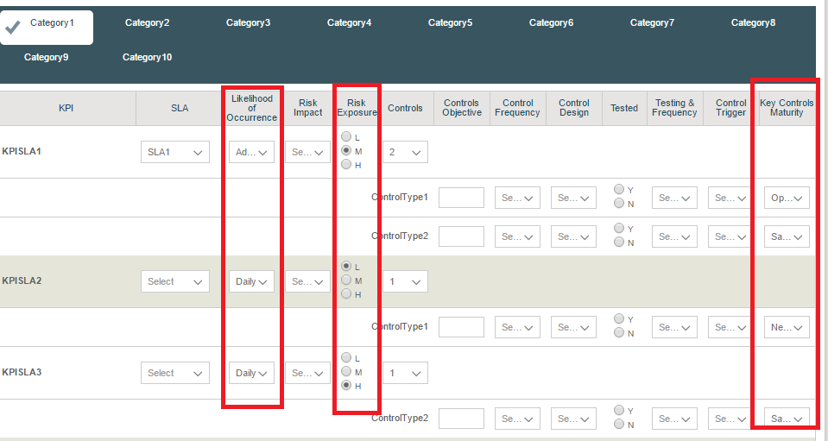
- Now, go to “Overall Risk Rating” tab. The graph should be drawn as
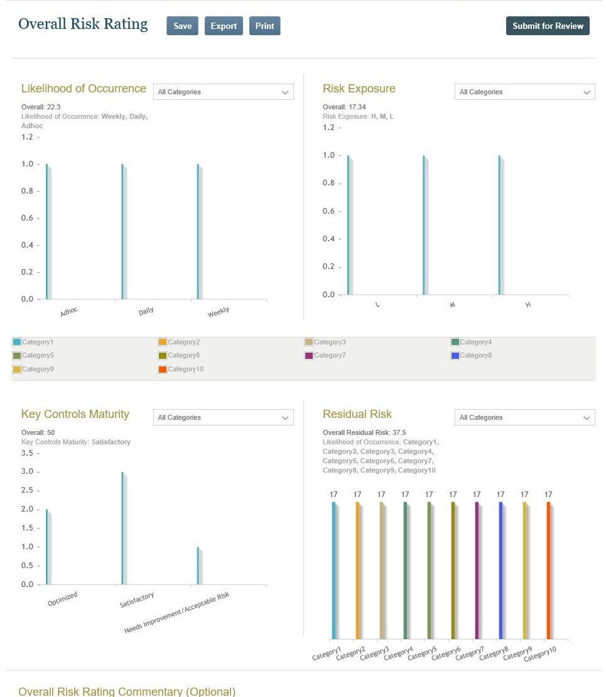
  - First chart depends on likelihood of occurrence selection. Please select from different categories 3rd tab to see more bars.
  - Overall Residual Risk will be always loaded.
  - Verify the filtering from dropdown to filter by category.

Resource Contact List

Name | Resource Email

